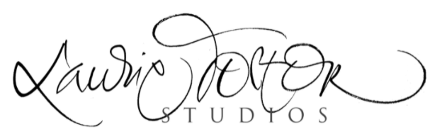

CLASS MATERIALS LIST

Cincinnati | 2024

We encourage you to print off this list and check off items as you pack them.

Pens & Pencils
- Bring your favorite writing & calligraphy tools (brushes, pens, pen holders and found objects)
- Pen Nibs: Bring a broad-edged nib (Speedball C-0), and a pointed nib (whatever you have, or Gillott 404)
- White china marker* (or white crayon, colorless candle, or white gel pen)
- Two fine-point pens* (Faber-Castell Ecco Pigment Pen 0.3, Pilot G-TEC-C4, or whatever you have in size 0.2 or 0.3)
- HB, 2B, and 4B pencils
- Pencil sharpener (recommend: German brass sharpener; no motors please)
- White eraser

Brushes
- No. 4 pointed brush, or choose one or two within the range of size 1-4 (recommended: No. 4 Silver Black Velvet 3000S)
- Cheap “paintbox brushes” or stencil brushes for mixing
- One wide brush, three or more inches wide (cheap foam brush, house painting brush, or Japanese Hake brush)
- Containers for rinsing brushes

Ink, Paint, & Gouache
- Walnut ink (walnut crystals are easy to pack)
- Windsor-Newton permanent white gouache or Dr. Martin’s bleedproof white
- Watercolors (red, yellow, and blue).

As long as you have tubes of good-quality (not student grade!) watercolors in red, yellow and blue, you will have enough to play with.

If you wish to try a new palette, and two versions of each primary color, I recommend the following colors (Daniel Smith colors are well saturated):Yellows: New Gamboge & Hansa or Lemon. Reds: Alizarin Crimson & Transparent Pyrrole Orange. Blues: Indigo and Ultramarine Blue.

- Containers with lids for ink
- Palette or small plastic cups (deeper wells are useful)

Paper
- Two sheets white Rives BFK paper* (22” x 30”; 250 gsm)
- One half sheet Arches Text Wove (25” x 20”)
- One sheet cover-weight paper for your book* (10” x 12” or larger; Arches Black Cover is one of my favorites and I will bring my favorite handmade paper for purchase)
- Tracing paper
- Notebook for taking notes

Bookbinding Supplies
- Embroidery or bookbinding needle
- Glue stick
- Right triangle
- Linen thread (2- or 3-ply)
- Paper clips (about 6)
- Rubber band

Other Supplies
- Scissors (not necessary if flying with carry-on luggage)
- Metal ruler with cork backing (12” or longer)

Optional Supplies (You do not need to bring these)

- Paper/ collage scraps
- Water-soluble graphite pencils
- Water Soluble Graphite Crayon and or Block (Art Graf or Lyra)
- Other tubes of gouache or watercolor: Peach Black (Holbein) is a lovely matte black
- Colored pencils
- Mat knife and cutting mat
- Bone folder

This class is reserved for those adventurers who are free and willing to leave phones, watches and any other electronics or time pieces outside the classroom. (This is a revolutionary idea in these times, but it is wonderful to reconnect with the part of ourselves that emerges in this sacred space, and it does make a difference to have them absent, not just off.)

You may need more or less paper, depending on how you work.

